Výsledky pre HU-Z2
Dataset: Imagenette 160 px (10 tried)
Inception-v3
Training log:
Epoch 1/5
403/403 ━━━━━━━━━━━━━━━━━━━━ 97s 189ms/step - accuracy: 0.8931 - loss: 0.4370 - val_accuracy: 0.9720 - val_loss: 0.0730
Epoch 2/5
403/403 ━━━━━━━━━━━━━━━━━━━━ 50s 121ms/step - accuracy: 0.9901 - loss: 0.0437 - val_accuracy: 0.9720 - val_loss: 0.0642
Epoch 3/5
403/403 ━━━━━━━━━━━━━━━━━━━━ 51s 124ms/step - accuracy: 0.9922 - loss: 0.0319 - val_accuracy: 0.9840 - val_loss: 0.0538
Epoch 4/5
403/403 ━━━━━━━━━━━━━━━━━━━━ 52s 125ms/step - accuracy: 0.9935 - loss: 0.0245 - val_accuracy: 0.9760 - val_loss: 0.0667
Epoch 5/5
403/403 ━━━━━━━━━━━━━━━━━━━━ 51s 124ms/step - accuracy: 0.9957 - loss: 0.0170 - val_accuracy: 0.9840 - val_loss: 0.0552
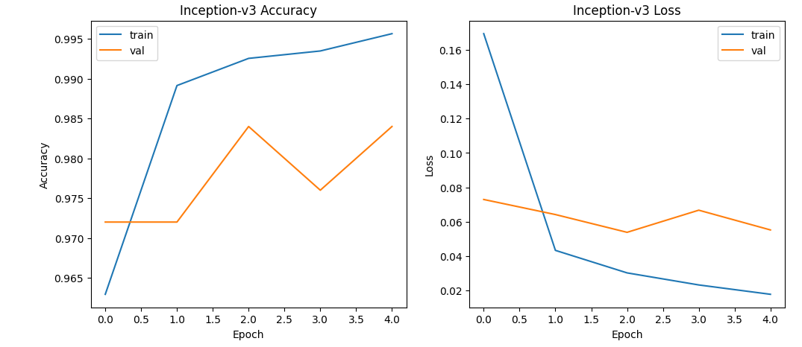
Inception-v3 Metrics:
accuracy: 0.98
precision: 0.980415750915751
recall: 0.9786666666666667
f1: 0.9792843737703384
latency_ms: 62.31246523272533
throughput: 16.04815338737102
Trénovanie + tetovanie zabralo 5 minút

Inception-ResNet-v2
Training log:
Epoch 1/5
403/403 ━━━━━━━━━━━━━━━━━━━━ 184s 376ms/step - accuracy: 0.9260 - loss: 0.3794 - val_accuracy: 0.9800 - val_loss: 0.0575
Epoch 2/5
403/403 ━━━━━━━━━━━━━━━━━━━━ 117s 289ms/step - accuracy: 0.9929 - loss: 0.0311 - val_accuracy: 0.9800 - val_loss: 0.0614
Epoch 3/5
403/403 ━━━━━━━━━━━━━━━━━━━━ 145s 296ms/step - accuracy: 0.9938 - loss: 0.0233 - val_accuracy: 0.9840 - val_loss: 0.0495
Epoch 4/5
403/403 ━━━━━━━━━━━━━━━━━━━━ 119s 293ms/step - accuracy: 0.9957 - loss: 0.0167 - val_accuracy: 0.9880 - val_loss: 0.0455
Epoch 5/5
403/403 ━━━━━━━━━━━━━━━━━━━━ 119s 294ms/step - accuracy: 0.9970 - loss: 0.0128 - val_accuracy: 0.9800 - val_loss: 0.0529
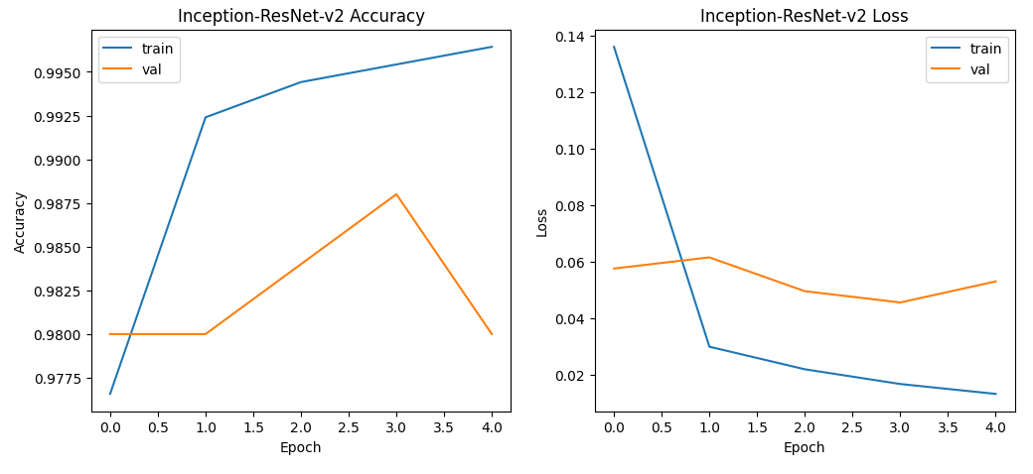

Inception-ResNet-v2 Metrics:
accuracy: 0.988
precision: 0.9884285714285713
recall: 0.9868333333333335
f1: 0.9874492397167168
latency_ms: 117.51732867784226
throughput: 8.509383350104594
Trénovanie + testovanie zabralo 12 minút

Dataset: timm/mini-imagenet (100 tried) (Hugging Face dataset)
Inception-v3
Training log:
Epoch 1/5
3125/3125 ━━━━━━━━━━━━━━━━━━━━ 379s 116ms/step - accuracy: 0.9010 - loss: 0.5458 - val_accuracy: 0.5342 - val_loss: 2.3011
Epoch 2/5
3125/3125 ━━━━━━━━━━━━━━━━━━━━ 356s 110ms/step - accuracy: 0.9684 - loss: 0.1579 - val_accuracy: 0.8372 - val_loss: 1.0881
Epoch 3/5
3125/3125 ━━━━━━━━━━━━━━━━━━━━ 351s 111ms/step - accuracy: 0.9858 - loss: 0.0686 - val_accuracy: 0.7652 - val_loss: 1.8276
Epoch 4/5
3125/3125 ━━━━━━━━━━━━━━━━━━━━ 346s 110ms/step - accuracy: 0.9871 - loss: 0.0628 - val_accuracy: 0.8372 - val_loss: 1.2823
Epoch 5/5
3125/3125 ━━━━━━━━━━━━━━━━━━━━ 343s 109ms/step - accuracy: 0.9894 - loss: 0.0541 - val_accuracy: 0.7736 - val_loss: 1.9524

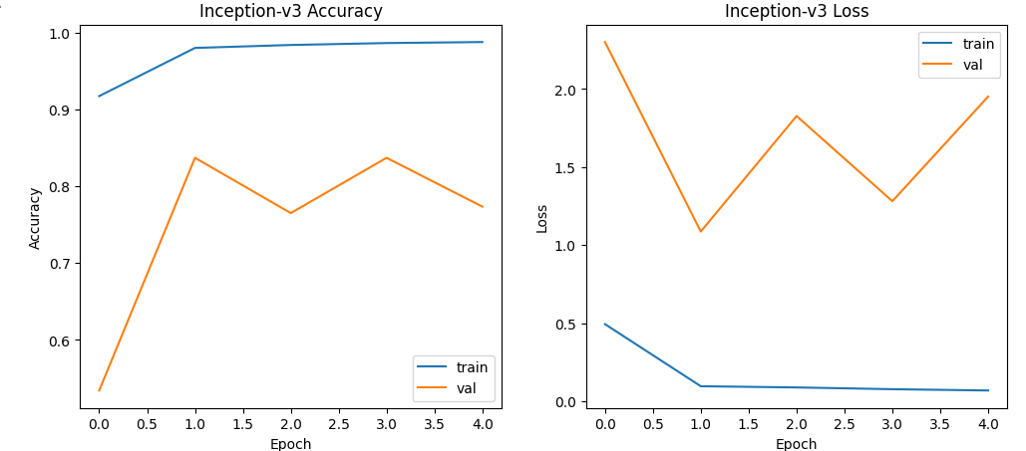
Inception-v3 Metrics:
accuracy: 0.6994
precision: 0.9243626113454319
recall: 0.6994000000000001
f1: 0.7587224892845909
latency_ms: 16.72397096888326
throughput: 59.79441137876926
Trénovanie + testovanie zabralo 30 minút

Inception-ResNet-v2
Training log:
Epoch 1/5
3125/3125 ━━━━━━━━━━━━━━━━━━━━ 654s 199ms/step - accuracy: 0.8983 - loss: 0.5866 - val_accuracy: 0.8630 - val_loss: 0.7134
Epoch 2/5
3125/3125 ━━━━━━━━━━━━━━━━━━━━ 607s 193ms/step - accuracy: 0.9792 - loss: 0.0839 - val_accuracy: 0.8399 - val_loss: 1.0223
Epoch 3/5
3125/3125 ━━━━━━━━━━━━━━━━━━━━ 607s 193ms/step - accuracy: 0.9894 - loss: 0.0511 - val_accuracy: 0.8428 - val_loss: 1.0753
Epoch 4/5
3125/3125 ━━━━━━━━━━━━━━━━━━━━ 607s 194ms/step - accuracy: 0.9890 - loss: 0.0532 - val_accuracy: 0.8863 - val_loss: 0.8024
Epoch 5/5
3125/3125 ━━━━━━━━━━━━━━━━━━━━ 606s 193ms/step - accuracy: 0.9908 - loss: 0.0463 - val_accuracy: 0.8474 - val_loss: 1.1362

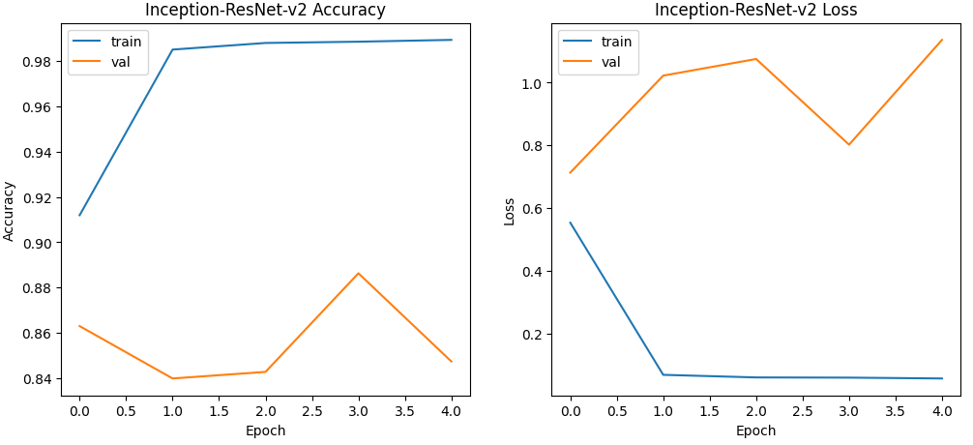
Inception-ResNet-v2 Metrics:
accuracy: 0.779
precision: 0.946006915128609
recall: 0.779
f1: 0.827253511034906
latency_ms: 25.903851841204464
throughput: 38.60429738905975
Trénovanie + testovanie zabralo 53 minút

